A000-US-SD-Lakota-Pipe Pouch-Beaded Cross-1840’s-1870’s.

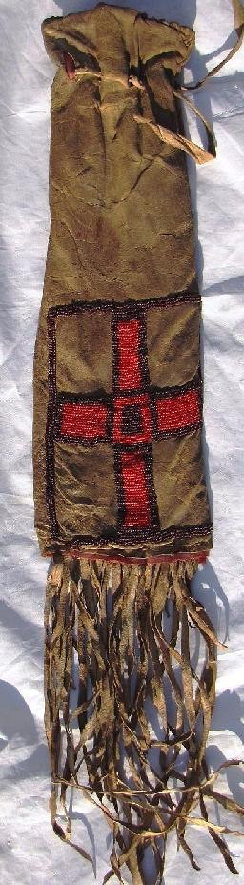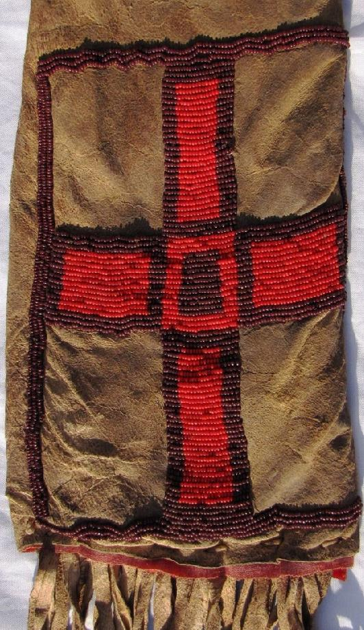

Lakota Sioux, brain–tanned buffalo hide, beaded pipe pouch, 1840’s-1870’s. Interior lined with red trade velvet and exterior sewn with expensive red and dark purple trade glass beads in the form of the four sacred cardinal directions crossing at the holy center. This suggests that this bag and its enclosed catlinite pipe and stem (both never conjoined unless used in a ceremony) were protected together with the band’s holy medicine bag.

Case No.:12

**Accession No.**

**Formal Label:** US-SD-Lakota-Pipe Pouch-Beaded Cross-1840’s-1870’s.

**Display Description:**

Interior lined with red trade velvet and exterior sewn with expensive red and dark purple trade glass beads in the form of the four sacred cardinal directions crossing at the holy center. This suggests that this bag and its enclosed catlinite pipe and stem (both never conjoined unless used in a ceremony) were protected together with the band’s holy medicine bag.

This suggests that this bag and its enclosed catlinite pipe and stem (both never conjoined unless used in a ceremony) were protected together with the band’s holy medicine bag.

**LC Classification:**

**Date or Time Horizon:**

**Geographical Area:**

**Map:**

**GPS coordinates:**

**Cultural Affiliation:**

**Media:** brain–tanned buffalo hideInterior lined with red trade velvet and exterior sewn with expensive red and dark purple trade glass beads Sewn with buffalo sinew. Grade 9 out of 10.  Unusual for this age with no bead loss.

**Dimensions:** Length: 15 in. with fringe 25 in.; Width: 5 in.

**Weight:**

**Condition:**

**Provenance:** Excellent Provenance: from the Native American Collection of Ralph Edward Guy who was listed in Who's Who in American Indian Relics.

**Discussion:**

**References:**